Aws Services

* There are three types of service in Cloud :-

1 = **IAAS** - (Infrastructure As A service)

2 = **PAAS** - (Platform As A sevice)

3 = **SAAS** – (Software As A service)

* Deployment Model of Cloud :-

1= **Public cloud** = Public cloud sis cloud computing that’s delivered via the internet and shared across organizations.

2 = **Private cloud** =  Private cloud is cloud computing that is dedicated solely to your organization.

3 = **Hybrid Cloud =** Hybrid cloud is a solution that combines a private cloud with one or more public cloud services, with proprietary software enabling communication between each distinct service .

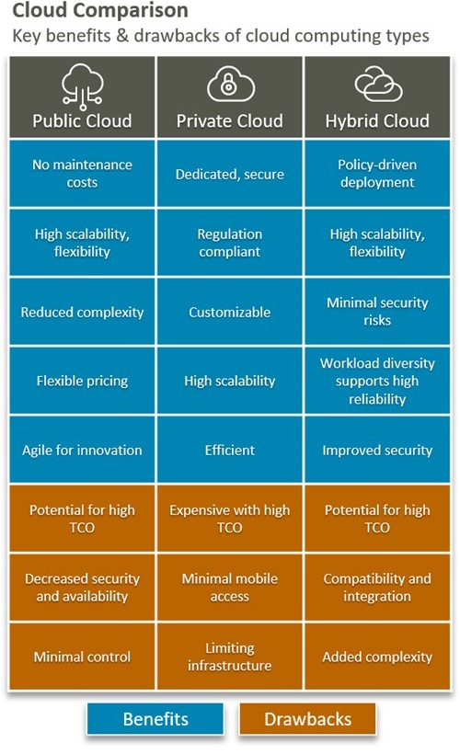

* **EC2 instance :-**

**===============**

* Amazon EC2 enables you to Scale up or Scale down the instances.
* By default, when you create an EC2 Account with amazon, your account is limited to a **maximum of 20 instances per EC2 Region** with two defaults High I/O insatnces :-

-------------------------------------------------------------------------------------------------------------------------------------

* **Why Amazon EC2?**

• Auto-scaling

• Pay-as-you-go

• Increased Reliability

• Elasticity

--------------------------------------------------------------------------------------------------------------------------------------

* There are several types of AWS instances with different configurations and benefits.

• **General purpose** - (Balanced memory and CPU)

• **Compute optimized** - (More CPU then ram)

• **Memory optimized** - (More Ram)

• **Accelerated Computing** – (Graphic optimized)

• **Storage optimized** – (Low latency)

• **High Memory Optimized –** (High Ram, works on Nitro System)

1. **General-purpose Instances :-**

General-purpose instances provide a balance among compute, memory, and networking resources, and they can be used for a variety of workloads.

* **Three series in general purpose are:-**

**(a) = A1 Instances**

**(b) = M5, M5a,M5ad and M5d Instances**

**(C)=M4 Instances**

**(d) = T2 and T3 Instances**

* **Instance available in four sizes :-**

• Nano,

• Small

• Medium

• Large

1. **= A1 Instances**

A1 instances are used in applications that work in synchrony with the Arm ecosystem and are suitable for scale-out workloads. They are suitable for these applications:

• Web servers

• Containerized microservices

• Caching fleets

• Distributed data stores

• Applications that require the Arm instruction set

1. **= M5, M5a, and M5d Instances**

These instances offer a balance among compute, memory, and networking resources providing an ideal cloud design. It could be used for a wide range of applications. M5 instances are well-suited for the following applications:

• Web and application servers

• Small and medium databases

• Gaming servers

• Caching fleets

Virtual-CPU -> 2 to 96(max)

RAM -> 8 TO 384(max)

Instance Storage -> EBS & NVMe SSD

1. **= M4 instances :-**

* The new M4 instances features a Custom Intel Xeon E5-2676 v3 Haswell processor optimized specifically for EC2

Virtual-CPU -> 2 to 40 (max)

RAM -> 8GB to 160 GB (max)

Instance Storage -> EBS Only

**(d) = T2 and T3 Instances :-**

* These instance provide a baseline level of CPU Performance with the ability to burst to a higher level when required by your workload.
* An Unlimited Instances can sustain high CPU Performance for any period of time whenever required
* These instances provide clock up or down of CPU performance. These instances are well-suited for the following applications:

• Websites and web applications

• Code repositories

• Development, build, test, and staging environments

• Microservices

Virtual-CPU -> 2 to 8

RAM -> 0.5 to 32 GB

•T2 micro is a free tier

1. **Compute-optimized Instances**

These instances are useful for compute-dependent applications that need high-performance processors. They are well suited for the following applications:

• Batch processing workloads

• High-performance web servers

• High-performance computing (HPC)

• Scientific modelling

• Dedicated gaming servers and ad serving engines

• C5, C4, and C5n are the instances under this category.

Compute Optimized Instances are Ideal for compute-bound applications that benefit from high performance processor.

* Powered by AWS nitro system

**C5 instances ->** C5 are optimized for compute-intensive workloads and delivers Cost –effective high performance at low price per compute ratio.

• Virtual-CPU -> 2 TO 72

• RAM -> 4 TO 192 GB(max)

• Network –Bandwidth -> 10Gbps Upto 25 Gbps,

•Instance Storage -> EBS Only & NVMe SSD ( In lowel-level server we use EBS & in some heavy-level server we use SSD & NVMe.)

* **Certification level question**
* **QUES1= How much EBS Volume support C5 ?**

**Ans 1= C5 Support max 25 EBS Volumes** means in 1 instance we can use 25 max EBS volumes like (1 root Volume & 24 EBS volume)

* **QUES 2 =Which network Adapter will use C5 ?**

**Ans2 = C5 uses Elastic Network Adaptor,** we also called as (ENA), We use this because when we use this our networking will be inhance it & in our networking all function will be improved it.

* **Ques 3= Which hypervisor does C5 use?**

**Ans3 =** **The C5 uses the new EC2 hypervisor** also known as the AWS NITRO system